NAME : SABINTHARAN S

REG NO:22CS082

1.Build a basic HTTP server that can handle different routes and HTTP methods (GET, POST, PUT, DELETE).

const http = require('http');

// Helper function to handle sending responses

function sendResponse(res, statusCode, message) {

    res.writeHead(statusCode, { 'Content-Type': 'application/json' });

    res.end(JSON.stringify({ message }));

}

// Create HTTP server

const server = http.createServer((req, res) => {

    const { method, url } = req;

    // Route: /

    if (url === '/') {

        if (method === 'GET') {

            sendResponse(res, 200, 'Hello, World! This is the root route.');

        } else {

            sendResponse(res, 405, `Method ${method} not allowed on this route.`);

        }

    }

    // Route: /items

    else if (url === '/items') {

        if (method === 'GET') {

            sendResponse(res, 200, 'Fetching all items...');

        } else if (method === 'POST') {

            sendResponse(res, 201, 'Creating a new item...');

        } else {

            sendResponse(res, 405, `Method ${method} not allowed on this route.`);

        }

    }

    // Route: /items/:id (using simple regex for demonstration)

    else if (url.match(/^\/items\/\d+$/)) {

        const id = url.split('/')[2];

        if (method === 'GET') {

            sendResponse(res, 200, `Fetching item with ID: ${id}`);

        } else if (method === 'PUT') {

            sendResponse(res, 200, `Updating item with ID: ${id}`);

        } else if (method === 'DELETE') {

            sendResponse(res, 200, `Deleting item with ID: ${id}`);

        } else {

            sendResponse(res, 405, `Method ${method} not allowed on this route.`);

        }

    }

    // Handle 404 - Not Found

    else {

        sendResponse(res, 404, 'Route not found.');

    }

});

// Server listens on port 3000

server.listen(3000, () => {

    console.log('Server is running on http://localhost:3000');

});

Output:

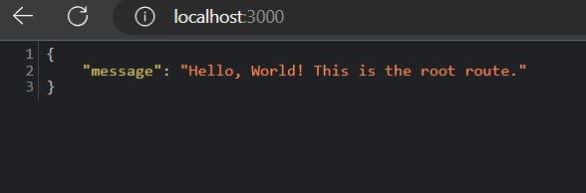

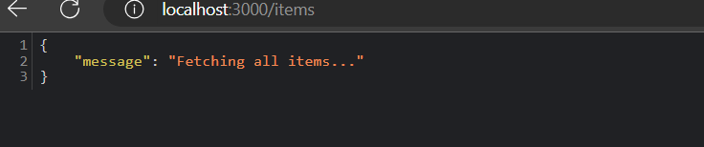

2.Create a server that allows users to upload files and save them to the server's filesystem.

const http = require('http');

const formidable = require('formidable');

const fs = require('fs');

const path = require('path');

const hostname = '127.0.0.1';

const port = 3000;

const server = http.createServer((req, res) => {

    if (req.method.toLowerCase() === 'get') {

        res.writeHead(200, { 'Content-Type': 'text/html' });

        res.end(`

            <form action="/upload" enctype="multipart/form-data" method="post">

                <input type="file" name="fileupload"><br><br>

                <input type="submit" value="Upload File">

            </form>

        `);

    } else if (req.url === '/upload' && req.method.toLowerCase() === 'post') {

        const form = new formidable.IncomingForm();

        form.parse(req, (err, fields, files) => {

            if (err) {

                console.error('Error parsing the form:', err);

                res.writeHead(500, { 'Content-Type': 'text/plain' });

                res.end('An error occurred during the file upload.');

                return;

            }

            const uploadedFile = files.fileupload;

            const oldPath = uploadedFile.filepath;

            const newPath = path.join(__dirname, 'uploads', uploadedFile.originalFilename);

            fs.rename(oldPath, newPath, (err) => {

                if (err) {

                    console.error('Error saving the file:', err);

                    res.writeHead(500, { 'Content-Type': 'text/plain' });

                    res.end('File could not be saved.');

                    return;

                }

                res.writeHead(200, { 'Content-Type': 'text/plain' });

                res.end('File uploaded and saved successfully!');

            });

        });

    } else {

        res.writeHead(404, { 'Content-Type': 'text/plain' });

        res.end('Route not found.');

    }

});

const uploadDir = path.join(__dirname, 'uploads');

if (!fs.existsSync(uploadDir)) {

    fs.mkdirSync(uploadDir);

}

server.listen(port, hostname, () => {

    console.log(`Server running at http://${hostname}:${port}/`);

});

Output:

